Update Naviace Student Passwords Quick Guide

Overview
On December 16th, 2019, Naviance updated password requirements for students and parents who log directly into Naviance Student with a username and password.
Password requirements are as follows:
  - Passwords must be at least 10 characters in length
  - The username may not be part of the password
  - Passwords may not include more than 2 identical characters in a row
  - Commonly used passwords, simple patterns, and common names will not be accepted
Passwords must always be kept private and stored securely.
You can update existing passwords to comply with the new security requirements in two manners:
  - Edit Password from your Naviance Student account
  - The Forgot your password? Link (if you have an email address on file in your Naviance account).
Naviance reset all passwords that had not been updated to meet the new requirements on January 27th, 2020.
  - If your password is reset by Naviance, and you do not have an email address on file in your Naviance account, contact your school for a temporary password.

Edit Password
This method requires that you can log in to Naviance Student with your current username and password.

If your password was reset by Naviance on January 27th, you must obtain a temporary password from your school prior to using Edit Password.
- Navigate to your school’s Naviance Student web page (https://student.naviance.com/accountname) and log in with your username and password.
- In Naviance Student, go to About Me > My Account.
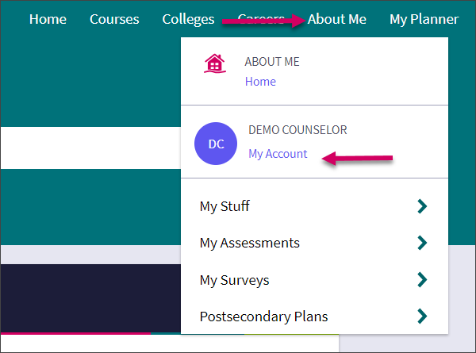
Step 1

- Go to Security.
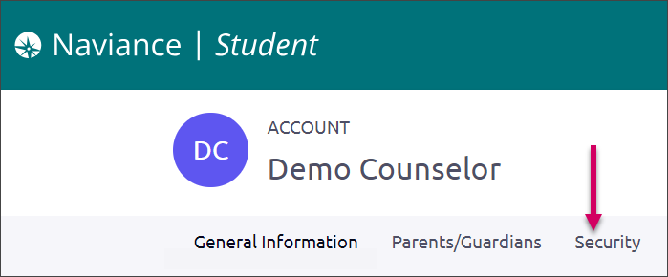
Step 2
- Select the option to Edit located in the Password card.
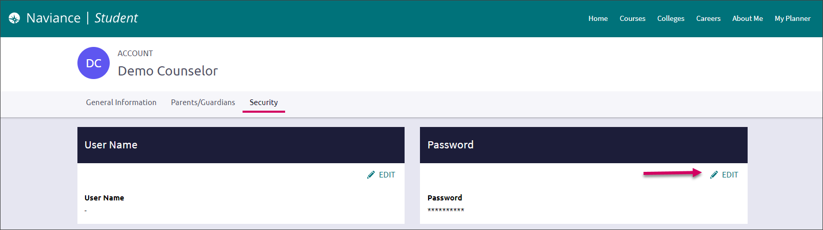
Step 3
- Follow the prompts to create a new password that complies with the updated password requirements.
- Click Save.
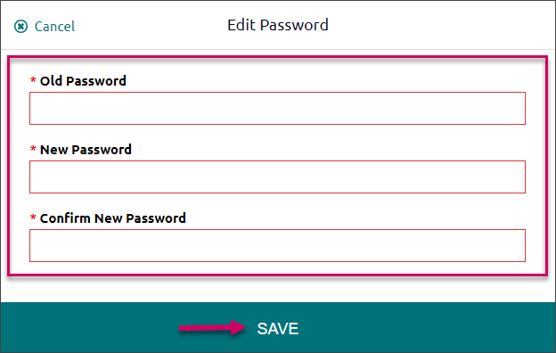
Steps 4 – 5

Temporary Passwords
If your password was reset by Naviance on January 27th, and you do not have a valid email address on file in your Naviance account. You will need to obtain a temporary password from your school.
After obtaining a temporary password from your school, follow the instructions for Edit Password, using your existing username and temporary password to log in.

You cannot use the temporary password to log-in to Naviance Student again. If you do not update your password prior to logging out, you will need to obtain another temporary password from your school.

Forgot Your Password
This option can be used to reset your password if you have an email address on file in your Naviance account.

If your password was reset by Naviance on January 27th, and there is not an email address on file in your Naviance account, you must obtain a temporary password from the school. Then, follow the instructions for Edit Password to reset your password according to the updated password requirements.
- From the Naviance Student login screen, select the accurate User Type.
- Select Forgot your password?
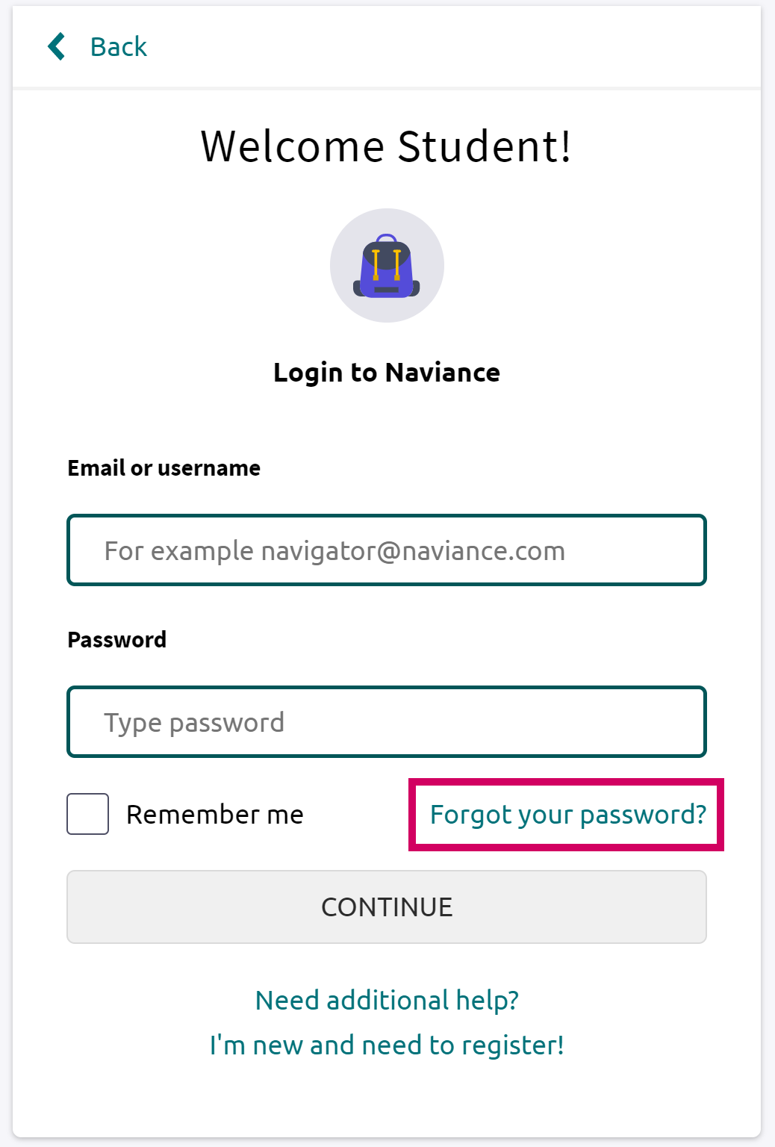
Step 2
- Enter the email address on file in your Naviance account. (If you do not have an email address on file in your Naviance account you can reach out to your school to request that they add an email to your account or provide you with a temporary password)
- Select Reset Your Password.
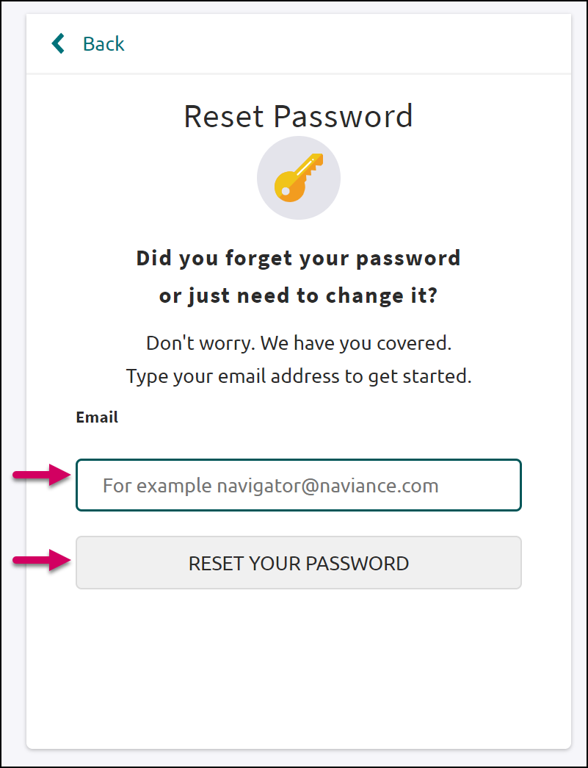
Steps 3 - 4
- Locate the Naviance generated email in your inbox. Use the provided link and make note of the temporary password.
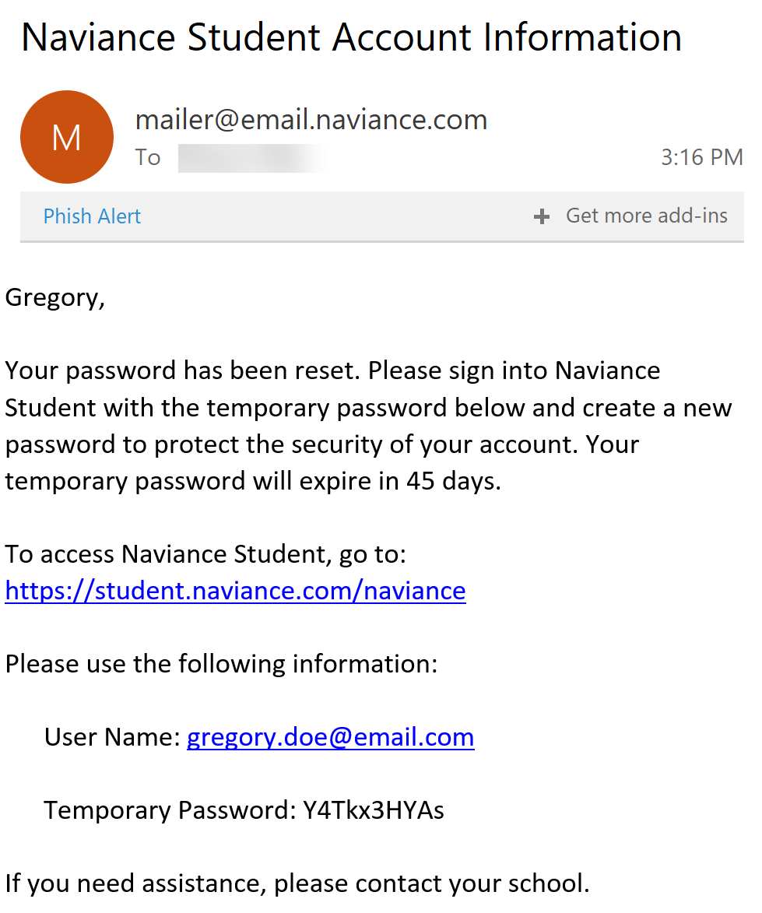
Step 5
- You will be returned to the Naviance Student login page. Select your User Type.
- Enter your Email or User Name and the temporary password you were provided.
- From the Reset Password page, enter and confirm a new password following the displayed requirements.
- Select Continue.
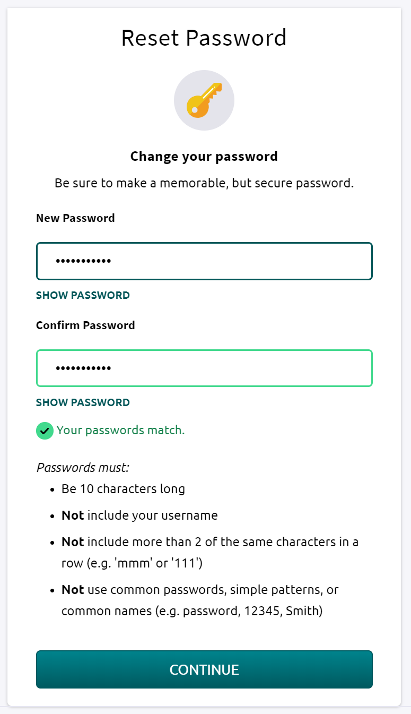
Step 8 -9
- You may now login to Naviance Student using your updated password.

